# CORS for API - Lambda

## <http://test-cors.org/>

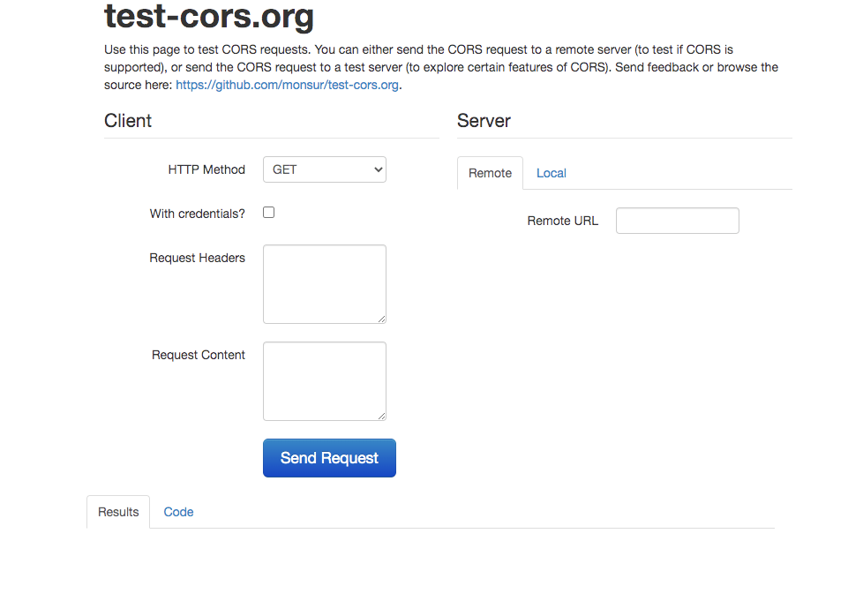

## Test the current endpoint

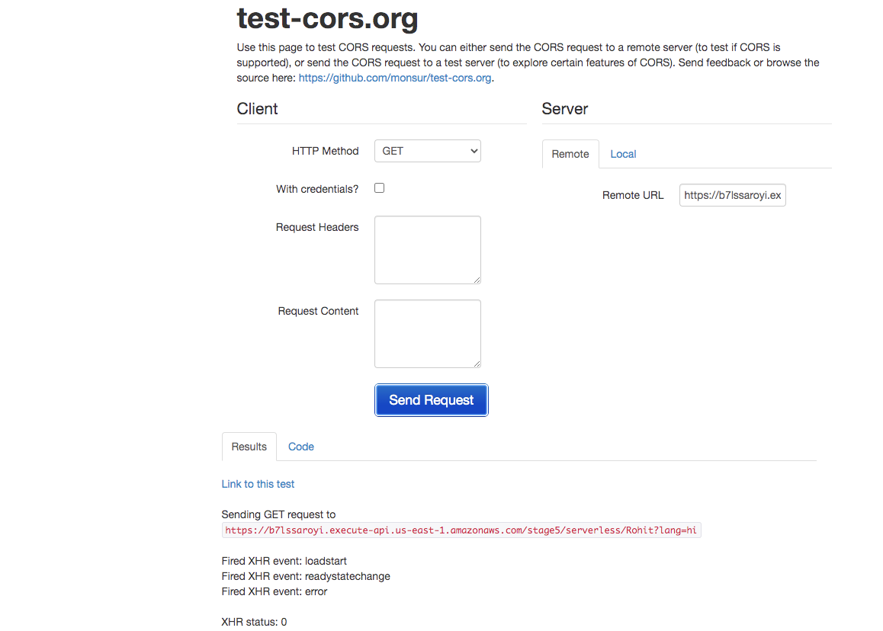

<https://b7lssaroyi.execute-api.us-east-1.amazonaws.com/stage5/serverless/Rohit?lang=hi>

Access to XMLHttpRequest at 'https://b7lssaroyi.execute-api.us-east-1.amazonaws.com/stage5/serverless/Rohit?lang=hi' from origin 'http://test-cors.org' has been blocked by CORS policy: No 'Access-Control-Allow-Origin' header is present on the requested resource.

b7lssaroyi.execute-api.us-east-1.amazonaws.com/stage5/serverless/Rohit?lang=hi:1 Failed to load resource: net::ERR_FAILED

DevTools failed to load SourceMap: Could not load content for chrome-extension://dgbldpiollgaehnlegmfhioconikkjjh/adblock/include.preload.js.map: HTTP error: status code 404, net::ERR_UNKNOWN_URL_SCHEME

### Method Response

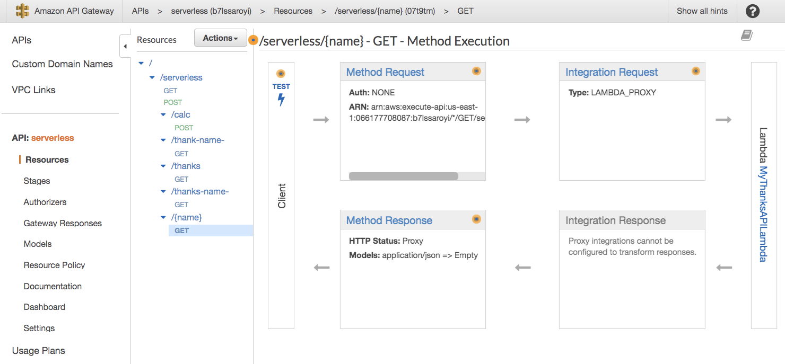

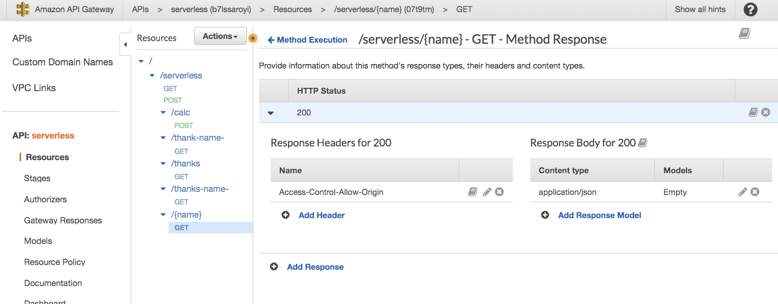

## Enable CORS in Lambda functions

const moment = require('moment');

const thanks = {

"en": "Thank you, Thanks",

"fr": "Merci",

"hi": "Dhanyavad",

"es": "gracias",

"jp": "arigato",

"ru": "spasiba",

"it": "Grazie",

"gr": "danke"

}

// Async handler

exports.handler = async (event) => {

// path parameter

let name = event.pathParameters.name;

// query parameter

let {lang, ...info} = event.queryStringParameters || {};

let message = `${thanks[lang] ? thanks[lang] : thanks['en'] } ${name}`;

let response = {

message: message,

info: info,

timestamp: moment().unix()

}

// return http response body for api gateway

return {

statusCode: 200

**,**

**headers:{**

**"Access-Control-Allow-Origin": "*"**

**},**

body: JSON.stringify(response)

}

}

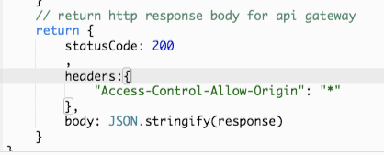

## Try again CORS to make sure it is working

